**Scatter Plots and Regression**

**Name:** Anushka Gupta **SRN:** PES2UG20CS060 **Class:** 5A

Determining what factors influence the speed of popular roller coasters. To investigate this question, you will use the coasters.xlsx file.

Connect to the coasters.xlsx file in Tableau.

Construct three scatter plots. For each plot, place the Explanatory variable on the x-axis and the Response variable on the y-axis.

Variable combinations:

* height and speed
* drop and speed
* duration and speed

**Question One:** Evaluate the regression conditions for each plot. Explain why or why not it is appropriate to run a regression analysis on each plot. Please address all conditions covered in this module.

**Answer:**

It makes sense to run a regression analysis on

Height-Speed Plot (Power Regression, R-Squared = 0.854) and

Drop-Speed Plot (Polynomial Regression, R-Squared = 0.9064)

But a Regression Analysis makes no sense on Duration-Speed Plot as the highest R-Squared value turned out to be 0.3056 using a Polynomial Regression Line

For plots that meet the regression conditions, add a linear trend line.

**Question Two:** Which variable(s) can you use to predict Speed?

**Answer:** Height and Drop

**Question Three:** What is the regression equation for the trend line(s)?

**Answer:** Equation are as follows

Height-Speed Plot

Height (ft) = 3.17831*Speed (mph) + -52.2067

Drop-Speed Plot

Drop (ft) = 4.47296*Speed (mph) + -140.32

For the plots that you conducted linear regression, drag Track (dimension) onto Color in the Marks card.

**Question Four:** Are there any differences between steel and wooden coasters in your analyses? Explain in few sentences.

**Answer:** Yes, there are various differences between steel and wooden coaster

* Tracks made up of Steel, from the same height, attains lower speed than tracks made up of wood
* For the rollercoaster to attain similar speed, the drop shall be higher for steel tracks than wood tracks

**Question Five**

Connect to the sample.xlsx file in Tableau. And demonstrate the following operations:

1. Row Calculation  
     
     
   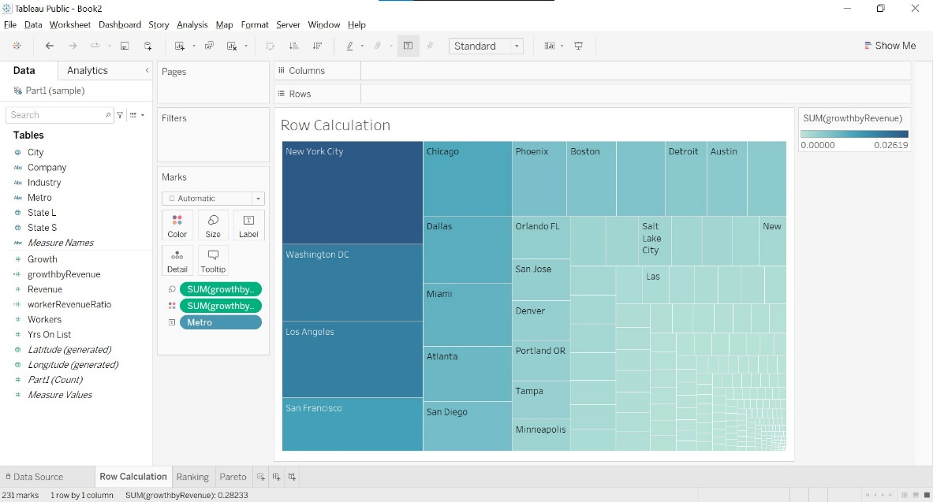
2. Calculate field  
     
   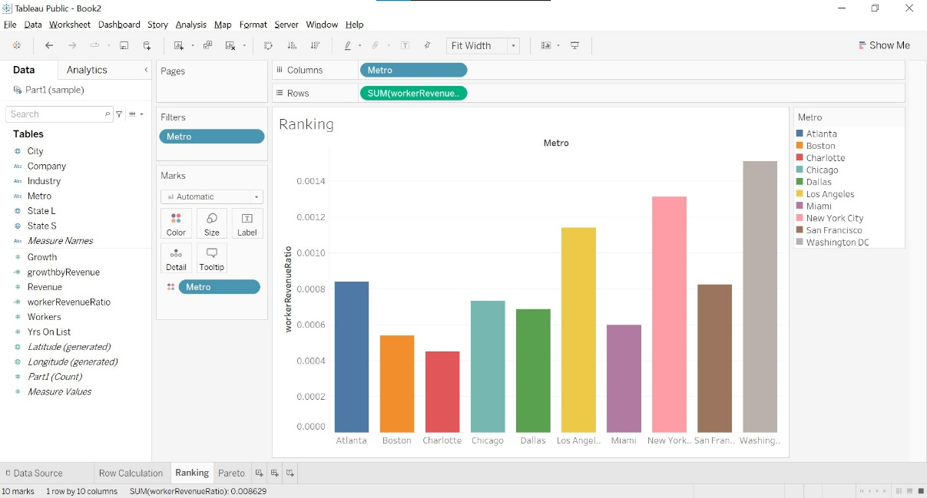
3. Table Calculation and Ranking

